Once upon a time, an uploader would put the direct links of the *material required* in his website. He would be supported by ads in his site. I would use Adblock Plus to block those ads, while getting hold of my links. Then came URL shorteners like [bitly](http://bit.ly/). But now, there are services which pay you for shortening your URLs. The catch: they would show ads to every visitor for some time, and only then would you get the link you are actually looking for. Adblock blocks those ads even now, but if your connection is slow, there are chances the "Skip this ad" button would not become active unless you refresh the page and go through the process again. However there is a shorter way to skip these ads if the "Skip this ad" button refuses to show.

[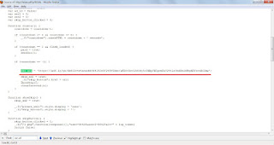](http://3.bp.blogspot.com/-q9omd7ZzY_U/T6J_vs0QXmI/AAAAAAAAAcU/WzRe9aLMzOc/s1600/1.jpg)

* Once your page has loaded and the "Skip this ad" button refuses to come up, press Ctrl + U to bring up the page source.
* Search for the string "var url" as shown in the screenshot.
* Select the link within the single quotes and paste in your browser's address bar. You'll be redirected soon.

Sometimes the pages seems to be locked. The URL pattern in that case is somewhat like this:  
  
http://adf.ly/locked/abcdef   
  
Change the URL and to http://adf.ly/abcdef and press Enter. You're good to go.  
  
Happy Downloading.